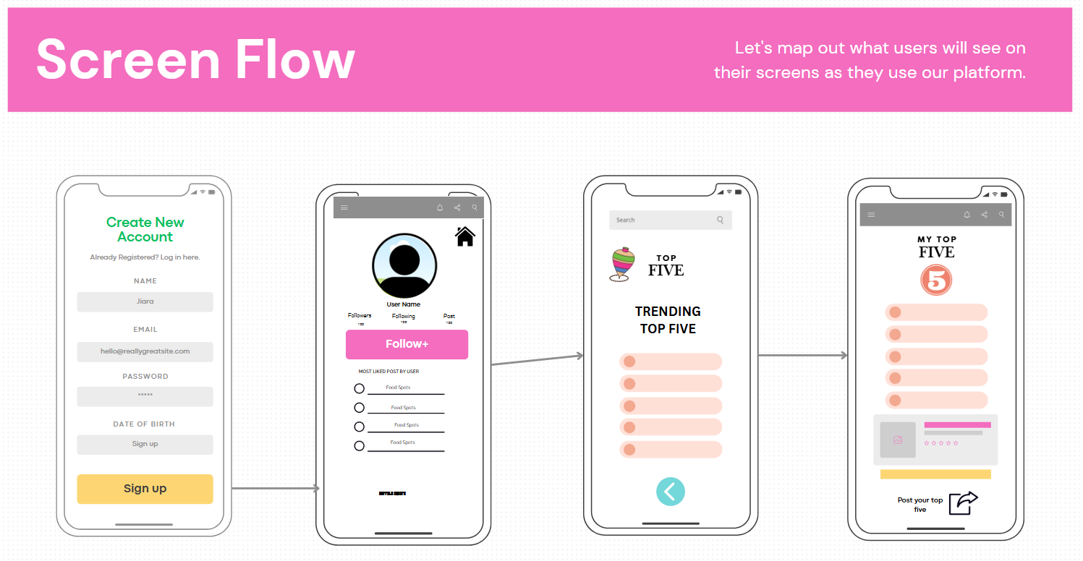

The design decisions for this program prioritize **intuitive navigation and user engagement** by using a straightforward flow: account creation, user profile, trending lists, and personalized posts. The clean layout, visible call-to-action buttons (e.g., "Sign up," "Follow+"), and a logical progression of screens ensure usability, high cohesion, and low cognitive load, aligning with class concepts like modularity and user-centric design. These elements aim to enhance user satisfaction and streamline interaction, as highlighted in discussions about maintaining simplicity and modularity in interface design.